13. ReactJS HandsOn

Create a React App named “bloggerapp” in with 3 components.

- Book Details
- Blog Details
- Course Details

Implement this with as many ways possible of Conditional Rendering.

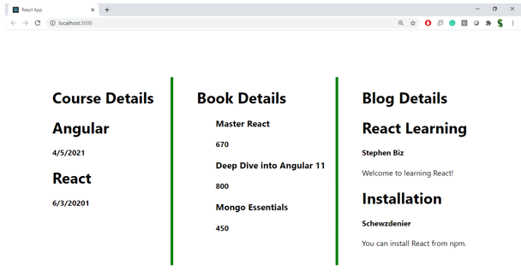

Hint:

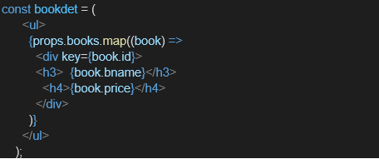

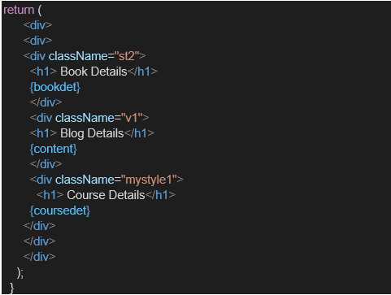

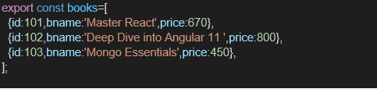

Project Structure:

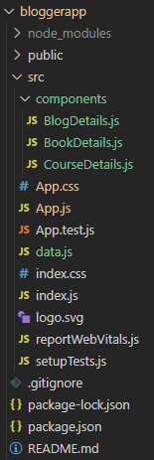
BlogDetails.js

// src/components/BlogDetails.js
import React from 'react';

const BlogDetails = ({ blogs }) => {
return (
<div>
<h1>Blog Details</h1>
{blogs.length ? (
blogs.map((blog, index) => (
<div key={index}>
<h3>{blog.title}</h3>
<p>{blog.content}</p>
<h5>{blog.author}</h5>
</div>
))
) : (
<p>No blogs available</p>
)}
</div>
);
};

export default BlogDetails;

BookDetails.js

// src/components/BookDetails.js
import React from 'react';

const BookDetails = ({ books }) => {
return (
<div>
<h1>Book Details</h1>
{books.length > 0 && (
books.map(book => (
<div key={book.id}>
<h3>{book.bname}</h3>
<h4>{book.price}</h4>
</div>
))
)}
</div>
);
};

export default BookDetails;

CourseDetails.js

// src/components/CourseDetails.js
import React from 'react';

const CourseDetails = ({ courses }) => {
if (!courses || courses.length === 0) {
return <p>No course details found.</p>;
}

return (
<div>
<h1>Course Details</h1>
{courses.map((course, index) => (
<div key={index}>
<h3>{course.cname}</h3>
<p>{course.date}</p>
</div>
))}
</div>
);
};

export default CourseDetails;

App.js

// src/App.js
import React, { useState } from 'react';
import BookDetails from './components/BookDetails';
import BlogDetails from './components/BlogDetails';
import CourseDetails from './components/CourseDetails';

import { books, blogs, courses } from './data';
import './App.css'; // Make sure you have this CSS

function App() {
const [view, setView] = useState('book');

const renderComponent = () => {
if (view === 'all') {
return (
<div className="all-container">
<div className="box">
<CourseDetails courses={courses} />
</div>
<div className="box">
<BookDetails books={books} />
</div>
<div className="box">
<BlogDetails blogs={blogs} />
</div>
</div>
);
} else {
return (
<div className="centered-box">
{view === 'book' && <BookDetails books={books} />}
{view === 'blog' && <BlogDetails blogs={blogs} />}
{view === 'course' && <CourseDetails courses={courses} />}
</div>
);
}
};

return (
<div>
<nav style={{ marginBottom: '20px', textAlign: 'center' }}>
<button onClick={() => setView('book')}>Book Details</button>
<button onClick={() => setView('blog')}>Blog Details</button>
<button onClick={() => setView('course')}>Course Details</button>
<button onClick={() => setView('all')}>Show All</button>
</nav>
<hr />
{renderComponent()}
</div>
);
}

export default App;
data.js

// src/data.js
export const books = [
{ id: 101, bname: 'Master React', price: 670 },
{ id: 102, bname: 'Deep Dive into Angular 11', price: 800 },
{ id: 103, bname: 'Mongo Essentials', price: 450 },
];

export const blogs = [
{ title: 'React Learning', author: 'Stephen Biz', content: 'Welcome to learning React!' },
{ title: 'Installation', author: 'Schwezdenier', content: 'You can install React from npm.' },
];

export const courses = [
{ cname: 'Angular', date: '4/5/2021' },
{ cname: 'React', date: '6/3/2021' },
];

App.css

/* src/App.css */

nav button {
margin: 0 10px;
padding: 8px 14px;
font-weight: bold;
border-radius: 4px;
cursor: pointer;
}

.centered-box {
display: flex;
justify-content: center;
}

.all-container {
display: flex;
justify-content: space-around;
align-items: flex-start;
}

.box {
padding: 10px;
width: 30%;
border-left: 6px solid green;
}

/* Remove left border from first box */
.box:first-child {
border-left: none;
}

Output:

